# Installation instructions for the ss3sim workshop – CAPAM 2015

There will be limited time (and internet) during the workshop and because of this, you will need to take some basic steps to **install and test ss3sim before arriving at the workshop on Monday**. We will not spend any time on installation or runtime issues.

The package works on Windows 7/8/10, MacOS and Linux, but we currently require R versions 3.2 or greater, and a 64 bit machine. If you have a 32 bit machine and really want to run models using ss3sim, follow instructions in Appendix A of the [vignette](https://cran.r-project.org/web/packages/ss3sim/vignettes/ss3sim-vignette.pdf) about setting the executable in your path.

Most installation issues arise due to R not being able to find the ss3 executable. Included in the installation of the package are binaries (executables) called ss3_24o_safe.exe and ss3_24o_opt.exe, for the “safe” and “optimized” versions of SS3.24o, specific to your OS. For the development version of the package, if these binaries are not found in your system PATH, then it looks for them in its installed files. That is, the binaries do NOT have to be in your PATH for the package to work, and they are NOT copied into each folder containing a model run. A single binary is used to run all models (even simultaneously in parallel). The easiest way to test if the package is “talking” to SS3 is to try running a simple simulation.

To install the package, open the “install.R” script contained in [this folder](https://github.com/ss3sim/workshop/archive/master.zip), in a new session of R (one with no packages loaded). Execute this script **line by line** and make sure each command is successful. This script will:

1. Install the necessary dependent packages using the devtools R package (you will NOT need Rtools for this installation – so ignore that warning if you get it). Make sure all the packages can be loaded successfully.  
     
   [NOTE: Some NOAA computers use a network drive which causes problems with installing packages. If you’re getting an error trying to install a package via `install_github` check your library paths with `.libPaths()’. If the first value (default) is a network drive, add a second local drive and install with ‘with_libpaths(new = .libPaths()[2], install_github("r4ss/r4ss"))’. This will tell it to install into the local folder. Contact the developers if that doesn’t fix it.]
2. Run a single replicate, which contains a folder for the OM and EM. Don’t worry about what this model is or where it goes. A successful run will say:  
   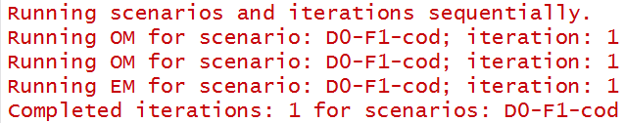
3. Check that the model output files were generated. If this is the case, the package is installed and ready to go. If not, please send any warning/error messages to us (Cole: [monnahc@uw.edu](mailto:monnahc@uw.edu) and Kelli: [kfjohns@uw.edu](mailto:kfjohns@uw.edu)) and we will help you get it working.

That is all you need to do for the workshop. We will be developing and running a simulation so bring your laptop with the folder if you want to follow along.